WMA 2025 Annual Meeting Evaluation
-----------------------------------------------------------------------------------------

PURPOSE

The Western Museums Association’s (WMA) 2025 Annual Meeting was held October 1-4 in Reno, Nevada. Around 350 attendees from across the West and beyond, came together to reconnect, learn from professionals in a variety of sessions, and attend fun networking events. To understand, evaluate, and improve upon the 2025 attendee experience, WMA sent out an Annual Meeting Evaluation. A total of 110 people responded; the results are shared below.

GENERAL QUESTIONS AND COMMENTS

This year, under advisement from the Programs & Innovation Committee, we started the survey by asking respondents, “How likely are you to recommend to a colleague to attend the WMA meeting in the future?” All 110 respondents answered. 88 (80%) said Very Likely; 19 (17%) said Somewhat Likely, 2 (2%) said Not Likely, and 1 (1%) said they were unsure.

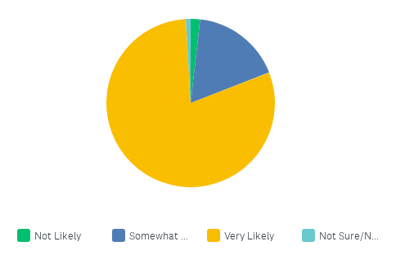

64 (58%) respondents left comments in the supplemental textbox asking “Why or why not?”. Many mentioned “good sessions” and “good networking” and “welcoming”. Here are some of them:

High quality presentations in a more accessible conference than the larger national-scale ones.

I had a fantastic time during my first WMA annual meeting. I enjoyed the range of sessions, but the best part was undoubtedly talking with colleagues from a range of disciplines and locations. It was a treat to attend a conference where everyone was interested in talking to everyone — it felt refreshingly un-cliquey.

I had such a great experience at my first WMA! This is an amazing community.

It was helpful to interact with both emerging professionals (like myself) and seasoned professionals. It was also very helpful to travel to other parts of the West and see what is happening there.

I was quite disappointed with this conference. It's the first time I've attended and was very unimpressed with the logistics, communications, accessibility, and overall feeling of catering to the sponsors rather than the attendees.

The opportunity to meet and learn from museum professionals representing so many different sizes and types of institutions as well as career paths was valuable for me. I believe this kind
of experience is unique to an event like the WMA meeting, therefore I would recommend it to a
colleague.

Great conference. Good sessions. Right quantity of people.

WMA feels like a community

While the information was wonderful, the networking well-coordinated, and the sessions
informative, the cost would be an issue for many that I know. It will actually prevent me from
ever attending again as well.

Coming from a museum in California, we have a large, active state museum association, and if
I were to recommend to someone to go to a general museum conference, I'd recommend either
AAM or CAM. The size and scope of the WMA conference was too in-the-middle. I also found
that many of the sessions didn't match their program summaries.(This was my first WMA
conference.)

Sessions were excellent, but more importantly the personal connections made were
Amazing lectures and individuals who are very open minded and creative!

Compared to big conferences like AAM, this was a personal, accessible way to get to know
fellow museum professionals. There was time to talk with the presenters, walk and talk with
other participants and really feel like a part of a community.

WMA is a mid-size conference that's easy to navigate and provides great opportunities
for networking and building strong relationships with peers.

I made great connections and learned new things!

High impact, low pressure conference. There was a great balance of sessions and space between scheduled sessions.

Great community, relevant sessions, fun evening events

I would somewhat recommend the WMA conference. It was a well-organized and welcoming event, and I appreciated the opportunity to learn from others in the museum field. As someone in Marketing & Communications, I found sessions on storytelling, community engagement, and branding interesting, but many focused more on interpretation or high-level concepts rather than practical, scalable marketing approaches. The branding session was good, though it leaned toward ideas that might be harder for smaller museums to implement. I’d love to see future conferences include more interactive, hands-on sessions focused on real-world marketing strategies and digital engagement that attendees can take back and apply right away.

---
The next general question asked, “At what stage are you in your career path?” Out of 110 respondents, 41 (37%) are Mid-career; 30 (27%) are Advanced-career, 30 (27%) are Emerging Museum Professionals, and 3 (3%) are New to the Museum Field. Of the 6 respondents that selected “Other,” 4 are independent consultants, 1 is in academia, and 1 was an exhibitor.
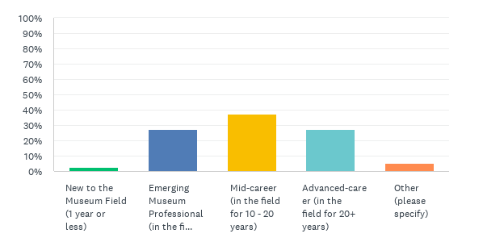
---
Moving to three Annual Meeting-specific questions, WMA first asked “What was your primary reason for attending the Western Museums Association 2025 Annual Meeting?” 104 of 110 respondents answered, as summarized below:
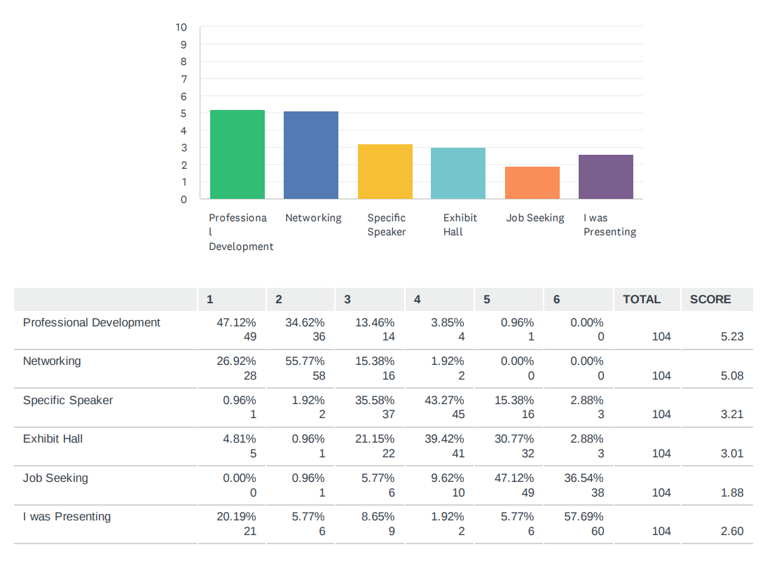
---
The fourth question asked if the Annual Meeting met their expectations. Out of 110 responses, 52 (47%) said it met their expectations; 32 (29%) said it exceeded their expectations; 24 (22%) said it met some, but not all, of their expectations, and 2 (2%) said it did not meet their expectations. This is nearly identical to last year’s responses.

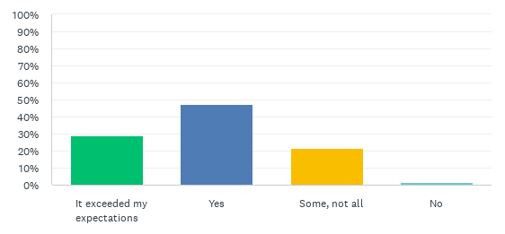
---
The fifth question asked survey respondents if they agree or disagree with the variety of statements seen below.

- 63 (57%) strongly agreed, and 42 (38%) agreed, that the meeting was well organized
- 66 (60%) strongly agreed, and 41 (37%) agreed, that the meeting was useful to them as a professional
- 57 (52%) agreed, and 40 (37%) strongly agreed, that the session material was presented at an appropriate level for their interest
- 62 (56%) strongly agreed, and 43 (39%) agreed, that there were enough networking opportunities
- 66 (60%) strongly agreed, and 42 (38%) agreed, that they had fun
- 62 (57%) strongly agreed, and 41 (38%) agreed, that this was a great meeting overall
- 41 (37%) strongly agreed, and 31 (28%) agreed, that they expect to attend next year. 27 (25%) were unsure.
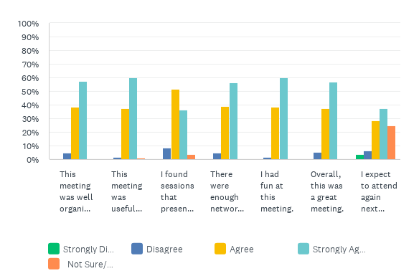
---
The second part of the survey focused specifically on the Annual Meeting Sessions. A total of 6 questions were asked in this section.

WMA began with questions 6a-e. Question 6a asked “What were the two or three best sessions you attended? What made them great?” A total of 76 attendees responded and 34 skipped. All sessions received at least one “Best” or “Great” vote, indicating overall satisfaction with this year’s sessions.

Here are the top sessions of WMA 2025:

These are the sessions attendees found to be the best session they attended:
7 attendee votes
Filling the Well: Elevate your Self-Care Practice
Museums in the 2nd Trump Administration
5 attendee votes
Beyond the Refrigerator Magnet: Brand Strategies that Fulfill Promise
4 attendee votes
Beyond Representation: Authentic Indigenous Engagement in Museums
Let’s Talk Leadership: Wins, Losses, and Everything in Between
These are the sessions attendees found also to be great:
5 attendee votes
Elevating Community Stories During Challenging Times
4 attendee votes
Let’s Talk Leadership: Wins, Losses, and Everything in Between
3 attendee votes
Exhibit Planning with Mission in Mind
Museum Experiences for Climate Change
Turn up the NOISE: Elevate Your Museums’ Strategic Plan
Beyond Words: Three Approaches to Test Titles and Messaging

These are the sessions attendees found to be good as well:
5 attendee votes
Beyond Representation: Authentic Indigenous Engagement in Museums
4 attendee votes
Many Voices: A Discussion with Native Leaders
3 attendee votes
Exhibits with Intent: Designing Exhibits as Platforms for Programming
Tending the Fire in Dark Moon Times
Come as you are…
Museum Experiences for Climate Engagement
Museums in the 2nd Trump Administration

Total Overall Positive Votes
11 attendee votes
Beyond Representation: Authentic Indigenous Engagement in Museums
Museums in the 2nd Trump Administration
10 attendee votes
Filling the Well: Elevate your Self-Care Practice
9 attendee votes
Let’s Talk Leadership: Wins, Losses, and Everything in Between
8 attendee votes
Exhibit Planning with Mission in Mind
Many Voices: A Discussion with Native Leaders

---
Next, 6b asked: “What was the least effective or valuable session you attended? What made it less than wonderful? How could it have been made better?” A total of 55 attendees answered, and 55 skipped.

WMA categorized the responses by session title. These were the top 3 least effective or least valuable sessions that received 5 or more votes:

- Exhibit Redesign: Strategies for Success (11)
- Reciprocal and Transactional Relationships (7)
- Elevating Your Mindset in Collections (5)

Below, are some the individual responses.

When your stuff doesn’t fit: Addressing collections facilities challenges 10/3. Felt like a sales pitch from the company. Examples were two very large museums and two very expensive projects. Needed tips/tricks on how to scale down ideas.

The spaces were uncomfrotable. It was almost impossible to see the speakers. From the keynote speaker, who wasn't lit, to speakers who say and couldn't be seen or hear, the sessions overall were difficult. So many sessions were baseline sessions - Museum 101 topics.

Turn up the Noise: Elevate your museum's strategic plan. This was essentially a pitch to sell their software. It was not scalable and there weren't any helpful takeaways other than, "come chat with us at our table".

All sessions I attended discussed outsourcing. Exhibit design companies were highlighted rather than in-house exhibit preparators, designers, installers etc. As an exhibit designer - who works in a shop - I found this theme repeated. So to pinpoint one session would not be fair. Every session that I attended fell into this. They were still insightful, just not practical.

Let's Talk Leadership. Presenters were great - but it's such a huge discussion and the area that so many museums are failing in, could have used more time and more opportunities for the audience to submit challenges and have solutions presented by the speakers.

WED 9 AM opening general session; opening remarks were really long; didn't feel the speaker was connected to the theme, western region, or relevant for me. Chairs in the museum were also really uncomfortable for such a long session.

I attended two leadership sessions that I felt were well intentioned, but fell flat. The culture of philanthropy session was also well intended, but involved way too much talking and there were limited opportunities to workshop the content. That relied heavily on design thinking, which is something you have to do, not be told, but there was a lot of talking.

Exhibit Redesign. Not all museums have the luxury of hiring out for re-design. I would have loved to see a mix of information for those that can and can't hire outside of the museum.

Keynote Speaker--wasn't what I expected or would've chosen to attend based on the subject matter. Keynote should have lifted us up and made a connection with our daily museum lives

EXHIBIT PLANNING WITH MISSION IN MIND: “BIG IDEAS” ELEVATE EXHIBITS -it was a good panel, however it focused on the problems that are being faced in this administration. which there is a problem, however we already know what to write or put on the website. the facilitator asked of people that became groups not to provide a solution to one another and then one of the panelist was in our group and began to provide solutions. and they knew that we were asked this.

EXHIBIT REDESIGN: STRATEGIES FOR SUCCESS. The session meandered and felt unfocused. I think they were talking about designing museums, not exhibits, but I'm not sure

ELEVATING THE VOICES OF OUR PEOPLE: THE JOURNEY OF THE SANTA YNEZ CHUMASH MUSEUM AND CULTURAL CENTER - could have been better-organized so they could get to all of the material they wanted to share

Turn up the Noise - needed an external voice (someone else who has used the techniques, or a client)

Exhibit Redesign: Strategies for Success All presenters are consultants, used too much jargon and seemed only modestly interested in museum related activities.

Reciprocal and Transactional Relationships (10/2 11:15AM). Felt repetitive and would have liked speakers from different types of museums instead of the same one.

---
6c asked, “What session formats did you find the most valuable?” Most popular was discussion or conversational learning (24 attendees), followed by active learning (14 attendees) and passive, panel-style sessions (10 attendees). Most of the written answers suggest that attendees enjoy sessions that start with a presentation and conclude with the opportunity to discuss and ask questions. Some also indicated that they enjoyed the mix of formats offered throughout the annual meeting.

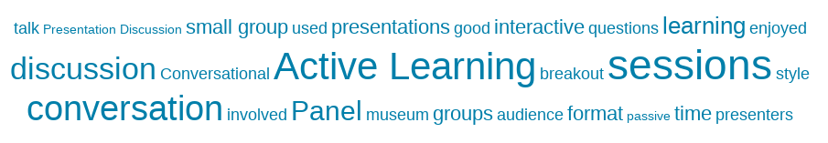

Out of 110 survey takers, 65 commented on session formats. Here are some:

I like conversations, but the presenters really have to be on top of keeping them focused

I prefer passive/active learning sessions with a portion of group chat or q&a. I don’t prefer the straight conversation sessions

I got a lot out of the roundtables, as well as the sessions that featured small group or partner discussions, as it was then I got to talk to other professionals and learn from them.

When the sessions are broken up into segments and each portion is aimed towards a different learning style.

The sessions that had a QR component where people could type in questions, answers, and thoughts anonymously were fun, novel, and helpful. Very interactive and fun!

there were a lot of panels and conversations which were a great way to make it personal and effectively address questions

"Workshop your museum's visitor experience" was the best session. A very clear and helpful framework that presented principles that I could easily apply to my work. The audience was engaged and it was the perfect blend of presentation with audience brainstorming and workshopping together.

Loved the poster session and round table formats - super engaging and well-facilitated. The sessions that had strong facilitation with Q&A built in throughout the session, plus time for us to talk in small groups or 1:1 were great.

I liked the panels, and the sessions where the presenters had obviously prepared. Handouts were awesome.

It's always good to involve the audience in some way, even if that's simply allowing 10-15 minutes for general questions at the end of the formal presentations. I appreciated sessions that included short blocks of time for small group discussion or questions.

Active learning! I loved the discussions and it allowed for great support and suggestions.

Interactive, small group discussions, personal connections with presenters

I like passive learning, I'm a bit more introverted

Like both active and passive learning. Love examples from other museums.

TENDING THE FIRE IN DARK MOON TIMES (SATURDAY 9-10:15) and USING EVALUATION AND DATA STORY TELLING FOR SUCCESSFUL FUNDRAISING (FRIDAY 11- 12:15)-both were interactive had the attendees involved.

---
Question 6d asked the survey takers to share any additional feedback about the sessions they attended. 30 of the 110 respondents (27%) wrote in their thoughts, and this is what some had to say.

This is a general statement not applicable to one session: I realized after the first day that many of the sessions for 101 or intros for folks who may be new to the topics, and I found that I wanted to dive deeper into issues / themes than the session planned to do. This helped me to pivot my approach, and I opted to attend a few sessions that weren't directly in my focus area but helped me to have a broader understanding of what matters to the field now / conversations that are happening.

Leaning toward museum-staff and partner led, avoiding companies or vendors highlighting their work over the museums.

It's very unprofessional to let sponsors present sessions. I think they could perhaps co-present with other professionals to offer one option, but attending a session to just be subjected to them selling their one product is a waste of my time as an attendee.

Some of the topics seemed geared toward medium to large museums ("small" being considered 44+ employees, I have 6) and I could not relate.

I found the sessions I attended to be geared to museums who could afford outsourcing. The amount of design firms on the panels were overwhelming and truthfully, unrealistic for a smaller museum. I think moving forward, I would love to hear about what solutions can be made inhouse and on smaller budgets.

The software a few sessions used to get immediate feedback and responses from the audiences that then got projected on the screen has potential. But it was a bit overused. We just stared at the screen for far too long.

I enjoyed that many of the sessions (i.e., AANHPI and collections) involved audience participation.

This was my 5th wma and it's boring to see the same EDs & Directors always talk. I would like to see more mid-level, managers, associates, and emerging leaders lead sessions

Most of the sessions I attended had 30 or less people. All of these sessions were in rooms where the setup could have been classroom (chairs and tables). Classroom setup makes it easier to take notes and would have been appreciated

I think all of the sessions needed to include tables for people to put their notebooks on and take notes. The chairs were also very uncomfortable, which was made even worse by the length of the sessions. For future conferences, please include tables for every session, and potentially more comfortable chairs. This should help with accessibility for those who can't balance their notebooks to write on.

Niki Stewart is fantastic in all her sessions. Loved her "ground rules!"

Being able to explore the host museum sites was a really nice experience.

I appreciated that WMA created space to include sessions about this unique moment, but I felt like there could have been more.

The keynote was good but lacked inspiration and had no connection to the conference theme.

Some of the rooms were not set up for conversations when the program was clearly open to that format. I think the session hosts were unclear on how the room would be set up

Everyone was really nice and I thought the land acknowledgments were great.

---
Question 6e asked, “As WMA prepares for 2026, how should we structure the new program compared to this year's program?” A total of 81 (74%) survey respondents answered. To highlight the responses:

Attendees Desire Same Amount of this Content
- 65% - Indigenous
- 62% - Collections

Attendees Desire More of this Content
- 51% - Visitor Experience
- 49% - Community Engagement
- 40% - Leadership

Attendees Desire Less of this Content
- 17% - Business

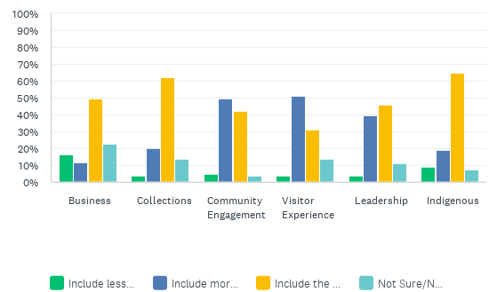

45 attendees shared their thoughts:

Fundraising

More on adapting programming to challenges and changing audiences. Comes through in sessions, but maybe as the main focus?

More about education, please!
Practical lessons: how to light a gallery, 10 steps to make your museum more accessible. I want tools to take home with me that I can implement at low/no cost.

Front-of-house topics like operations management

Environmental Topics

I wish there had been more general museum education sessions. Many of us were museum educators and we all attended sessions that weren't really meant for us.

Exhibit Production

I would like to see more cultural specific session such as Asian, Black, LGBTQ, etc

A stronger focus on the visitor experience through the lens of the visitor; not solely behind the scenes development of exhibit experiences, but what truly shapes an experience—the visitor perspective. I suppose this is also part evaluation. Maybe a session that connects these topics with personas in a workshop setting?

I wish there had been a more effective session about navigating organizational change. It was a good session of identifying how people respond to change, but I do not feel any more equipped to navigate organizational change than I did before the session. I think there is a lot of room for sessions next year to focus on navigating change.

How to expand your membership. How to move members to Donors.

More development sessions. The culture of philanthropy one was kind of a dud, and I wish there was more inspiring content in that area, especially now when our institutions are really challenged in terms of revenue.

Something around managing up in the museum workplace/workforce

Education programs - specifically sessions for educators, docents, tour guides.

Please keep including sessions in marketing and advancement!

Education! Educators are the front lines presenting information at many museums and they are always the least-represented at conferences.

Small Museum - focused on volunteer-run or 1 or 2 paid staff.

Professional development--in terms of learning how, as an emerging professional, to engage with colleagues: how to network, how to handle difficult emails, how to introduce yourself. A starter kit for building professional confidence. The secret handshake for museum professionals--how to fake it til you make it.

Exhibit design, exhibit process, from design through fabrication

---
Next, Question #7 asked the survey takers if they found the 2025 Opening General Session & Keynote speaker Dr. Kirsten Pai-Buick, to be valuable. A total of 87 people responded – 40 (46%) voted “Yes;” 25 (29%) voted “Somewhat”; 12 (14%) did not attend; and 19 (12%) voted “No.”

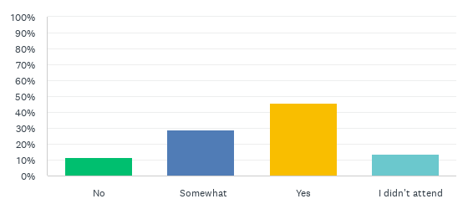

23 people elaborated further on why they found the Opening General Session and keynote to be valuable or not. Here are some:

I really enjoyed Dr. Buick's keynote talk. She was an engaging speaker, and it was a nice balance of academia and practical approaches to interpreting art. I shared a few of her thoughts about landscape with a colleague who is putting together a university class on the topic.

I loved that this keynote was so academic. I loved the complex ideas she was able to share.

It was a great start to the conference! Perfect for the state of the world we live in now

It was a history lesson, but the tie in to WMA was extremely tenuous. I'd like a speaker who is laser focused on inspiring and raising up the museum community.

It started off good and then got heavily academic so i started to glaze over a little

It didn't feel connected to the theme or western region. If there is only one general session I want to be energized by attending.

The opening session and the keynote were too long. I think the awards should be separated into a different lunch or reception to better award recipients, and to break up the time people are required to sit in one place. I suggest keeping the opening remarks shorter, or have fewer people introduce before you get into the actual keynote. The keynote speaker was well prepared, but her content left much to be desired for people wanting a museum presentation. It was also not inspiring at all, and cast a depressing pall on the sessions immediately afterward.

Dr. Buick is brilliant and I loved her presentation. But it was crazy dense with content and maybe not the best for that format.

I really liked hearing from an academic about their research in a way that was broadly applicable to modern life. It was different from what I'm used to and I enjoyed it.

Needs to include more of a pep talk at the end

---
Now, the survey enters the third section focusing on Networking and the Exhibit Hall.

In Question #8, WMA wanted to gauge just how much the Saturday morning Inspiration Stations and Roundtables facilitated networking opportunities. Of the 110 survey takers, 82 answered and 28 skipped. 29 (35%) respondents said they were unsure. 25 (31%) felt they were “Very Helpful” and 23 (28%) “Somewhat Helpful,” while only 5 (6%) respondents felt they were” Not Helpful.”

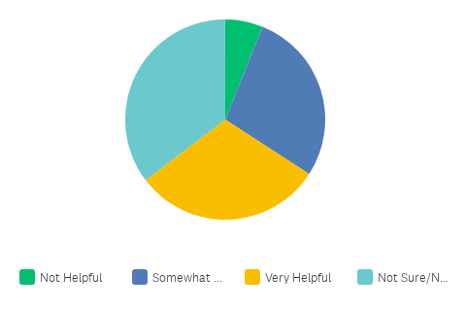

Here is some of what attendees had to say about this year’s Roundtables and Inspiration Stations:

I was unclear on the roundtable format. I was speaking to an inspiration table and then all the roundtables were talking and it felt rude to sit down so I ended up missing it. Setting expectations of whether or not it's ok to jump in and out, or encourage facilitators to be more welcoming would be nice.

There were several things happening at the same time so I felt like I missed out.

It was unclear if we were allowed to move between tables and felt very awkward to join other groups that were in the thick of discussion. Would have been helpful to have timed rounds so it would be more clear and effective for discussion.

It was too loud and close together--I couldn't hear anything

I liked being able to speak with new individuals, and I even connected with former acquaintances

The only downside was too many interesting ones!

I really liked the roundtables. I found them to be more useful than big presentations.

Was only able to spend time at 1 table. The presenter provided information that took the whole time, wasn;t able to go to others.

It was kind of crowded at some tables, not a lot of space sometimes. Difficult to join a full table. But having the space to get up and walk around is good and talk about different topics quickly is nice. As in the ability to bounce around was nice.

---
Next, attendees were asked “What kind of networking event would you most like to see in the future?” 41 (37%) responded and 69 skipped. Here are some attendees’ suggestions:

Speed networking was actually very helpful

more space for the networking events. many filled up or were in shared spaces and made it difficult to join. Maybe more breaks to continue conversations and develop relationships.

I really enjoy conferences with 20-30 minutes between sessions to have ample time to speak with presenters and to network. I really enjoy the feeling it creates to not be rushed and be able to chat with folks.

Informal, social meetups at a location off-site where attendees could just chat freely without too much structure or expectations.

This year had a good mix.

Food and drink within any type of museum does it for me!

Speed networking was great, maybe more round tables at the beginning of conference

Speed networking was appreciated! Please use a bell or a shaker next time - the whistle jarred my nervous system (:-)). And, a room with better acoustics - or meeting outside for this - would be less jarring as well. Thank you!

I feel that the networking events were quite successful. I do enjoy those that also have an activity component—whether in the form of a workshop or other unique gamified component.

The roundtables were particularly effective for networking and would like to see those again.

All were great! I liked ones based on problems people were working to solve, so we could come and discuss issues and strategy at our institutions.

Something not focused on alcohol

DEIA mixer

Events besides happy hours--or more non-alcoholic/fun alternatives to wine and beer.

There is already a great diversity of opportunities.

Divided by type of museum and equal representation.

More sessions of speed networking or something similar.

---
Question 10 asked the survey takers to let WMA know if/how the Exhibit Hall served their interests during the Annual Meeting. 46 (42%) answered, and 64 skipped.

8 people simply answered yes. These were some of the key responses/critiques.

Good swag! I wasn’t in need of an contract/vendor services this year. But I have met some great vendors in the past.

Enjoyed the exhibit hall far more than I expected to. Liked the "hub" and vendors. Wish lunch had been in a separate space during the WMA open lunch.

It didn't. The only time I went to the exhibit hall was during the networking lunch on Thursday and was incredibly disappointed that there was no actual places to eat and network with folks. There were a few cocktail tables, but that is not a comfortable---or accessible---way to eat. Also, I got there about twenty minutes the event (scheduled for and hour and fifteen minutes) and the food was gone. I saw many other people come in after me and left without food too. It was such a negative, unwelcoming experience that I never returned to the exhibit hall.

only somewhat, it was dead in there most of the time, outside of the scheduled happy hours, and then people were chatting with one another mostly, not really talking to the exhibitors that much. It would be much better to have the exhibitors in an area where people are walking back and forth through the space to get to program sessions... this space was set aside as a satelite on its own, and was mostly void of people for long stretches of each day.

I engaged more than ever in there. I liked the sticker idea this year, but I didn't keep up with it. I really enjoyed talking with the collections and exhibit production vendors.

Mostly, not enough places for small groups or a couple of folks to go off to the side and chat.

I didn't find any of the exhibitors helpful- I would have liked to see more about programming and tours instead of just building related exhibitors.

Great! Loved the seating areas and snacks. Having gluten-free cookies/options of snacks would be so appreciated as often it was the glutinous items at break times that were available/left.

I enjoyed the networking events that took place in the Exhibit Hall, as this created a fun, energetic environment. Having the raffle prizes in the space provided other points of interest and opportunities for conversation I would have liked to see more of a variety of booths, and not so many focused on software or design businesses. A booth from Roman and Littlefield or other museum content publishers would have been really great

Great place for snacks and to continue networking between sessions.

Good selection of vendors but could have been more robust.

Silent auction was great, enjoyed posters, talked with vendors, but not much of what they had to offer was useful for my position

---
The fourth and final portion of the survey, “You get the last word,” focused on obtaining feedback for next year’s conference in Salt Lake City.

This section started with Question 11, “What is one thing the Annual Meeting organizers could have done to make your experience better?” 52 responded and 58 skipped. This is what some attendees had to say:

Add city/state to the attendee list!

I found the multiple locations physically challenging especially the distance to Saturdays Venues. The food tables, in the exabit hall, were not at ADA height.

This was my second WMA conference and the feeling of "a good ol' boys club" continues. If you know folks, you're in and cool. If you don't - good luck. I find WMA to feel unwelcoming and lacking on the little details. For instance, why ask us our dietary needs if they aren't going to be accommodated. Don't do dairy? Tough, there is no dairy alternative, not even for coffee. Other details were missing too - I had the privilege of going on the Stewart Indian School tour. The driver had not been communicated with regarding drop off or pick up. No one thought to mention that the gift shop only took cash or check. As museum professionals we spend money in gift shops, that's how we support. When it comes to accessibility, this conference was tough. The music was always on - trying to listen to a poorly lit keynote with music playing overhead made it nearly impossible to focus. It was often REALLY difficult to hear speakers and the screen were small and hard to see. For anyone with low vision and low hearing, this conference was a bust. The food wasn't labeled - I have a serve Pineapple allergy and left the evening event feeling terrible because none of the food was labeled and I had an allergic reaction.

Communication: When I arrived on Tuesday evening, I couldn't find any info in emails, the online program book, or at the hotel about where registration was. I thought perhaps I wouldn't worry about it until after the fieldtrip, but then saw people with lanyards Wed morning and asked them where they had gone to register. A simple sign in the lobby or an email the day before with that info would have been an easy way to address this issue. I also really appreciate it when I go to conferences that send a daily email. It's a helpful reminder of what's going on and a good way to give people a heads up of big changes (like the fact that NONE of the sessions on Saturday were actually on site and travel time would need to be allotted). Finally, as mentioned above, signage around the meeting space would have been helpful. The Pyramid Room in particular was especially tricky to find the first time since you're walking down a corridor with hotel rooms, so it's anti-intuitive that you're going the right way.

There was some dissatisfaction related by some members of the Nevada museum community in regards to: 1. being brought in on the host committee after much of the groundwork had already been laid with the Nevada Museum of Art. They felt there was no space for their suggestions to be included and that they were summarily dismissed. 2. that the program did not take into account the high percentage of small, rural museums in the state of Nevada, and that the solutions provided in sessions were out of reach of museums of their size. The program focused too much on larger, well-heeled, well-staffed institutions. 3. Many local museum professionals that did attend related that they felt that WMA was not the place for them, and would not attend again in the future.

Released the final program a little earlier

suggestions for good restaurants. safety suggestions/reminders, walking buddies

better food options and activities at receptions

Put attendees before (or even equal to) sponsors. While we understand sponsors help pay the bills, it often feels like their needs are put ahead those of attendees.

Provided shuttles or buses in between venue sites- walking in the rain was not fun and it was a distance on Saturday to the other two venues

I would have liked fewer paid events. The tickets for this conference were already quite expensive, and $40 for a lunch or light refreshments seems like a lot on top of that fee. the NMA conferences (smaller and less expensive) often have much more included, so I was a bit disappointed.

Lunch was gone before I got there on Thursday. More food!

This was a great conference - all the issues that I came across were beyond the control of conference organizers. This was a fun -- but full -- conference. It did overfill my cup, and trigger a bad migraine as a result. I wish there was a way to know there was access to sessions that were missed, either to rest/recharge or for whatever the reason -- such as access to Ppts / handouts, similar to what they do at AAM. Then I also wouldn't have felt guilty for prioritizing health -- or having conflict over sessions when two great ones were pitted against each other in a time block. Not have both Native-themed pre-conference tours on the same day--can't choose!

Tech help! My session--Museums in the 2nd Trump Admin--got off to a rough start because we needed tech help to connect my laptop to the screen. There were instructions on the Topaz Room screen, but I did not understand them. A volunteer came to help who also seemed confused, although he eventually solved the problem. One of our speakers was very soft spoken; having a mic would have helped.

Larger conference venue, the second floor events were loud and crowded. It was overly stimulating.

included at least one evening event. They are very valuable (for networking, relaxing, visiting new places) but can be cost prohibitive - and some organizations don't allow to purchase them with a pcard. I had to keep referring to the program for the upcoming sessions, and find the right page in the program... I would have loved to have the entire schedule of sessions at a glance, grouped by time, both in the program and on a sign in the venue.

Make the program ( PDF) better formatted for review on a Phone.

The lunches cost too much. Since they are sponsored, why do they cost so much? These could be good networking times if they are more inclusive.

Make it clear that you need to buy their own meals. The lunch provided one day was mediocre and everything was gone by the time I got there. The evening events did not have enough food to fill someone up. It's fine to be on your own for meals, but wasn't really clear in advance.

Shift the programming to be weekdays only

Pay attention to the details such as the 'coffee, tea and snack' service. The coffee ran out at every morning event, there was no hot water for tea in the afternoons and the food was gone within only a few minutes for the 'receptions'. Not enough chairs for lunch seating was very uncomfortable, not enough chairs for keynote event, people stood through over an hour of preamble and program without complimentary coffee available. Signage for session rooms at Automobile museum was sketchy and confusing. Some session rooms at the conference hotel were virtually impossible to find.

Some sessions that were somewhat similar overlapped - I found that several times I was interested in more than one session at a time

More free meals :D the free lunch was nice, but the option for each day would have been more convenient for those not going to the paid lunches.

Leave time to explore the museums in the area!

Next, WMA asked what Annual Meeting organizers should keep in mind as they plan for WMA 2026 in Salt Lake City, Utah. 34 answered and 76 skipped. Some attendees’ responses are as follows:

Keep up the good work! WMA is a well-oiled machine. I love the consistency of high level sessions and variety of networking and learning events/sessions.

Make time to explore the amazing nature so close to downtown Salt Lake!

Y'all have been hosting conferences for decades, 90 years, create yourself some checklists to remember the things that are often forgotten or feel last minute. Figure out how to welcome newcomers. Take photos of folks you don't know or haven't met. Your board and executive director should make an extra effort to greet and say hello to folks that look unfamiliar. Otherwise, you should just call the conference a reunion. So many of the sessions are geared toward medium to large organizations. Telling a museum about hiring a company to survey 600 folks to test an exhibit title is ludicrous.

Be more focused on the attendees than the sponsors by: 1) Creating a program that doesn't include sessions of sales pitches, 2) Communicate clearly by sending a daily email and have good signage, 3) Schedule more time between sessions for networking, 4) Offer more general sessions and if food is provided please order enough and have places to actually sit down and eat together.

having everything within walking distance was real treat! try for that in SL.

Please ask caterers to label the food as GF, V, etc. Otherwise, keep up the good work!

Walkable events work really well. Having the evening events within walking distance was really great.

Please make sure that panelists are not there to sell their products. And consider a three day rather than four.

Keep up the Fun!! being able to learn and network in a fun relaxed environment is wonderful! I feel like I am surrounded by family for the duration of the conference.

As you consider your next conference, please think about the little museums in some of these great big western states. For many of us in Nevada, this was the only opportunity we will ever have to attend a conference of this size and caliber. The cost is huge. Many of us are volunteers and living on a fixed income. We are still professionals, but limited by funding. A session that speaks to volunteers doesn't do any good if the volunteers aren't able to attend the conference.

You are doing amazing work and we are all grateful!!!

I need help figuring out how to be a presenter! How does it work? What do people want to see? Some attendees came on their own, and meeting new people can be intimidating. If you offered a 'Solo Traveler' meetup on the first day, it might help them find a buddy early.

Use an ADA lens when making decisions - use classroom seating instead of theater, include microphones, only schedule sessions offsite when there is a relevant reason, if a meal is provided with the registration fee there should be enough food for all attendees (this is the third year in a row the food has run out before the end of the line. More sessions from small museums and a variety of museums - for example, I run a historic house museum and there were no sessions on that type of museum that I saw.

I think my top suggestion is to make the rooms more comfortable and collaborative (include tables for writing on or group work, and better chairs). I also suggest condensing the opening session so that people can remain excited and motivated as they move into sessions. Recognize award winners in a separate session.

Actively recruit education/programming museum professionals to present sessions.

Keep including Native topics, and presenters who are Native - incredible perspective was shared in Reno - would like to see this continued in SLC.

Keep it fun! It's so much more than the sessions.

I can't say how much I appreciate this conference. It feels like home.

Why do we have to meet on a Saturday? It means you lose your whole weekend of your personal/family time between attending sessions and traveling. If it must be on the weekend. Be sure to end no later than 2:30 so people can catch a flight home that evening. Start on Tuesday instead of Wednesday.

We really enjoyed the last night of games. I think it would be a great ice breaker to have in the beginning during a break time or first evening hang out to get to know others through playing games. Stories/storytellers have become a bigger topic within communities. Maybe a subject to touch on more?

Be mindful which businesses and organizations this conference will be funneling money into as Utah is a polarized state and I believe we should be bolstering economies that share our community values. The banning of LGBTQ+ flags makes me feel as if the state/location may not be accepting of all individuals and WMA should be a safe space for all of our colleagues.

I appreciated the exhibit hall game so that attendees had more incentive to connect with the vendors.

Include at least one nighttime event in the cost of the full conference registration. I would rather pay more for the entire conference than have to pick from $40 events with only 'appetizers' as dinner. Give us one event that everyone attends and enjoys together.

It was cool to have some things at the automobile museum but that walking across the street was not super enjoyable. And low-key unsafe as we definitely started being lax about crossing the street.

---
To conclude the survey, Question #13 invited attendees to write comments we might use for social media. 10 people left comments, but only 5 were usable/relevant for our social media content. Those responses are:

I am so full of joy and vigor after the 2025 WMA conference. Do what you can to make it to Salt Lake in 2026!!!!

This was my first WMA conference, and I am already so excited for next year. In the short few days, I met so many great people!

WMA is warm, friendly, open, and welcoming. I've gone to museum conferences all over the country, and these are the best. Smart people figuring things out together.

I can't say how much I appreciate this conference. It feels like home.

I heard about resilience and caring, collaborations and partnerships, and a deep love of museums and community. WMA is just the right size to network and become inspired.

